Day in the Life of the Hudson River 10/14/21
Peebles Island State Park
RIVER MILE: 154
Salt Front: ~ 49
D. Lee Magadini & Berkshire Waldorf High School
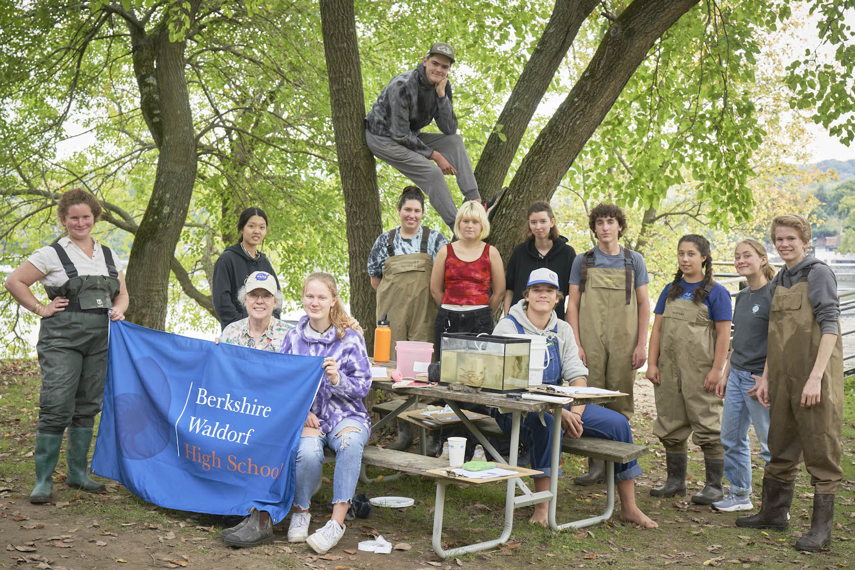
12 students (9th-12th grade) & 2 adults
Latitude 42.78 N & Longitude – 73.68 W
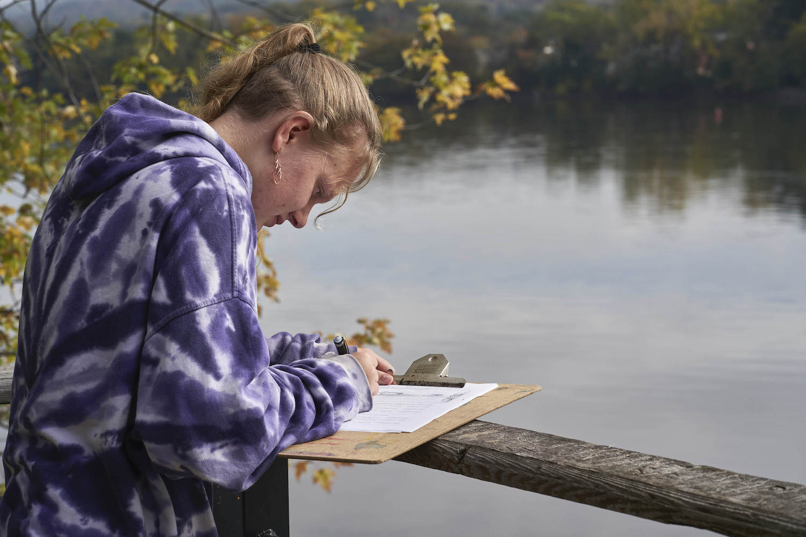 | 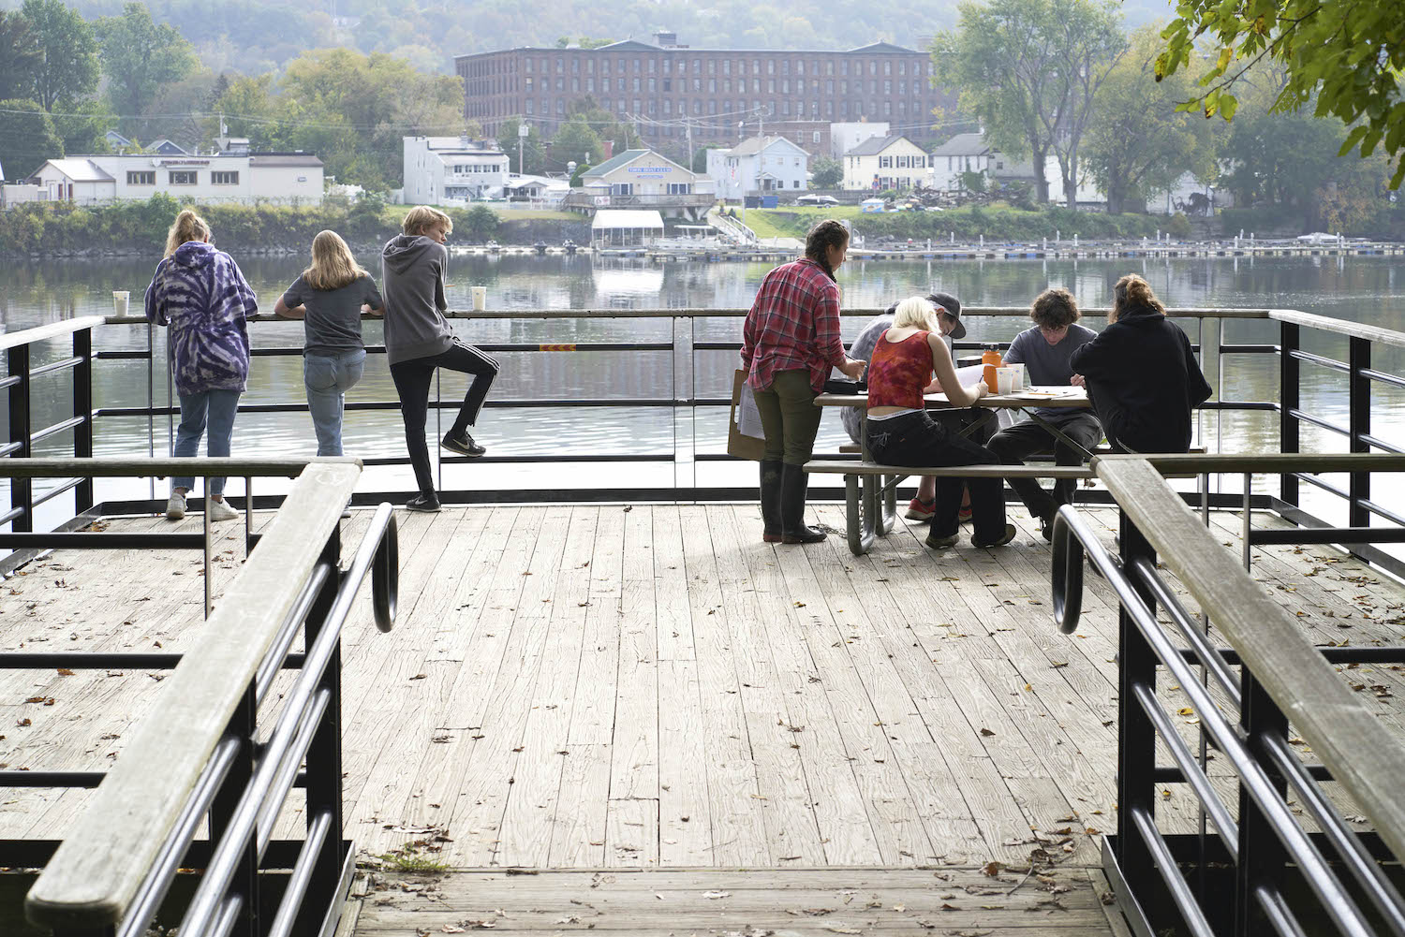
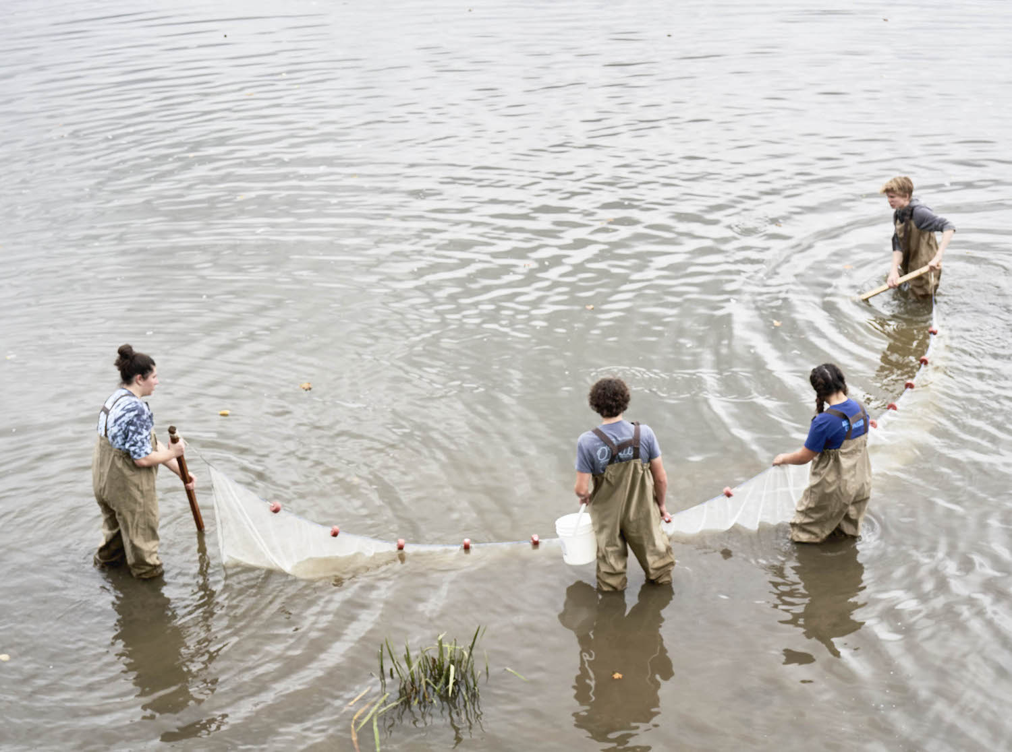 | 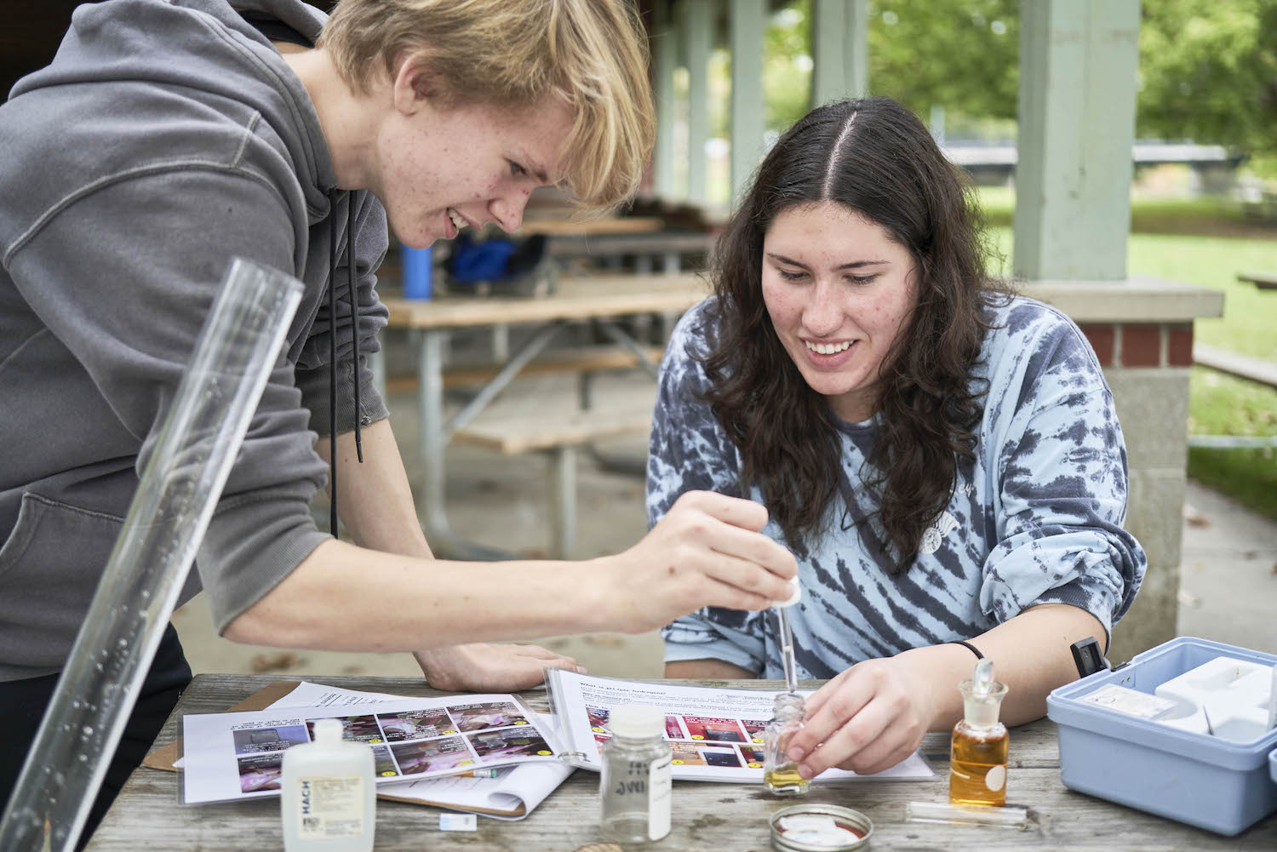
Location: Peebles Island State Park
Area: A large grassy riverside park with many trees surrounding an open pavilion with picnic tables inside and an overlook that has 180° view of the Hudson River.
Surrounding Land Use: 55% Urban/Residential; 20% Forested; 5% Industrial/Commercial; 10% Beach; 10% Roadways and Bridges.
Sampling Site: Forested, grassy, covered in vegetation, parking lot. A beach with altered banks that have stairs to the water.
Shoreline: 10% Sandy, 80% Muddy, 10% Rocky
Water: Calm, estimated depth of 25 cm.
Plants in area: 25% Eurasian water milfoil; 5% Willow
River Bottom: Muddy, rocky and weedy
*NR = Not read/recorded
ITEM |  | Time |  | Reading |  |  |  | Comments
Physical
Air Temperature |  | 11:37 AM  12:31 PM  1:34 PM |  | 21.128 º C  22.24 º C  22.24 º C |  |  | 70 º F  72 º F  72 º F
Wind Speed: |  | 11:25 AM |  | Anemometer  2 mph |  |  | Beaufort  1 | Direction  SW
Weather today |  | 9:55 AM |  | 51-75% cloud cover |  |  | No rain
Weather the past 3 days: |  | Unseasonally warm and clear
Tides- |  | Time |  | Rising, Falling, Unchanged |  |  | Height (cm)
Above the head of tide |  | 11:35 AM-12:00 PM |  | Unchanged |  |  | 25.5 cm
Current- |  | Time |  | Cm/sec |  | Knots | North/South | Ebb/Flood/Slack
Rate of Flow |  | 11:44 AM  11:53 AM  12:22 PM  12:30 PM |  | 6.9  0  4.5  6.7 |  | 0.134  0  0.0914  0.13 | South  NA  NR  NR | NA  NA  NA  NA
Water Temperature- |  | 11:35 AM  1:38 PM |  | 19.4º C  20.02 º C |  |  | 66.92º F  68 º F
Turbidity- Long Sight Tube |  | 11:14 AM  11:53 AM  2:11 PM |  | 60.4 cm  52.8 cm  66.32 cm
Chemical
Salinity- Low Range Quantabs |  | 11:12 AM  12:35 PM  2:07 PM |  | 37 ppm Cl-  28 ppm  37 ppm |  |  | 67 ppm TS  *Below Detection  67 ppm TS | Any salinity would have been background from geology or road salt
Standardized Salinity- Low Range Quantabs |  | 9:50 AM |  | BD
DO – Hach Drop Count Kit |  | Time |  | Temp |  |  | ppm DO | % Saturation
 |  | 11:35 AM  1:38 PM |  | 19.4º C  20.02 º C |  |  | 10  12 | 103%  130%
pH – Color Match Kit |  | 11:26 AM  12:35 PM  1:53 PM |  | 7.5  8.0  7.5
Nitrates- NR
Phosphates- NR
Biological
Fish - |  | Number |  | Name |  |  | Length of longest | Length of smallest
Seine – 5 pulls |  | 17  66  1  1  4 |  | Spottail Shiner  Banded Killifish  Brook Silverside  Smallmouth Bass  Tessellated Darter |  |  | 6 cm  10.5 cm  6 cm  7 cm  5 cm | NR  4 cm  NA  NA  NR
Fish Totals |  | TOTAL: 89 |  | Diversity: 5
Macroinvertebrates |  | Number |  | Name |  |  | Length of longest | Length of smallest
Macroinvertebrate Totals |  | TOTAL: 0 |  | Diversity: 0
Sediment Core - NR
Length | H2S smell |  | Oxid Top |  | Oil |  | Grain Size | Other Features
Boats
 | Time |  | Name |  | Color |  | North/Southbound | Light/Loaded
Commercial- None
Residential | 10:41 AM  10:55 AM  12:31 PM  2:11 PM |  | Unnamed  Seaplane  NR  Starcraft- small fishing boat  Starcraft |  | White  Gray & Black  Brown  Gray & Black |  | Southbound  Southbound  Southbound  Northbound | Light  Light  Light  Light

